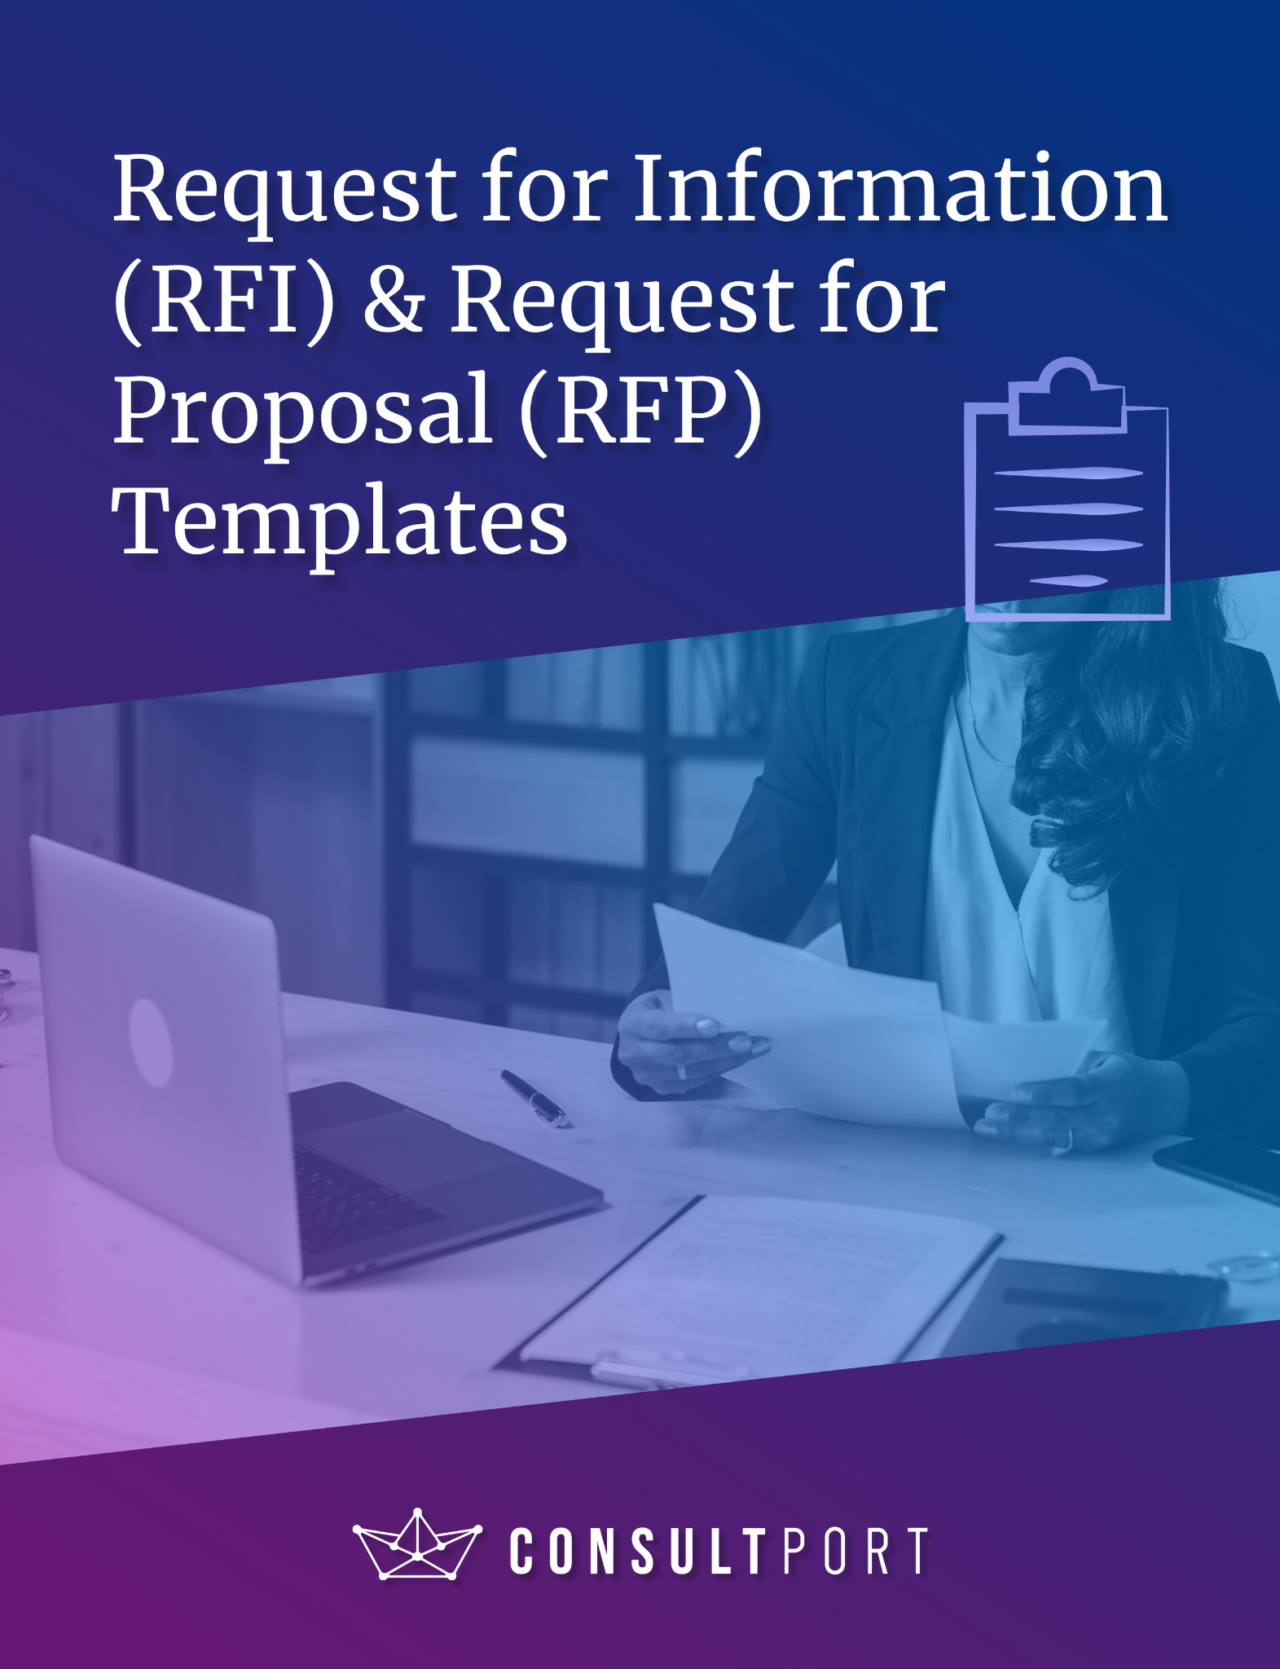

# 

# 

# What are Request for Information (RFI) & Request for Proposal (RFP)?

Request for Information (RFI) serves as an initial step to gather essential background information about potential suppliers or vendors. They are designed to assess the qualifications, capabilities, and general profiles of prospective suppliers. RFIs are primarily focused on information gathering and supplier screening, without delving into the detailed proposal.

Request for Proposal (RFP) is a formal and comprehensive document used in the procurement process. It comes after the RFI stage and is sent to pre-qualified suppliers. RFPs outline the specific requirements, scope of work, and expectations in detail. Suppliers responding to an RFP are expected to provide thorough proposals, including detailed pricing, project plans and specific timelines. RFPs represent the formal stage for soliciting detailed proposals and ultimately selecting the supplier.

# 

# 

# 

# 

# 

# 

# RFI Template (Example)

|  |  |
| --- | --- |
| Company Information | |
| Company Name | Innovative Solutions Manufacturing, Inc. |
| Project Name | IT Service Enhancement |
| Main Point of Contact | Sarah Johnson |
| Email Address/ Phone Number | [sarah.johnson@innovativesolutions.com](mailto:sarah.johnson@innovativesolutions.com) / (555) 789-0123 |

|  |
| --- |
| Project Goals |
| * Improve IT infrastructure to enhance operational efficiency. * Enhance cybersecurity measures to protect sensitive data. * Streamline IT service delivery for internal stakeholders. |
|
|
|

|  |
| --- |
| Submission & Evaluation Timeline |
| * RFI Release Date: October 1, 2023 * Deadline for Vendor Inquiries: October 15, 2023 * RFI Response Submission Deadline: November 1, 2023 * Anticipated Vendor Shortlisting Notification: November 15, 2023 |
|
|
|

|  |
| --- |
| Requested Information |
| *Vendor Information*   * Legal company name, year of establishment, and ownership structure. * Contact information, including key personnel, phone numbers, and email addresses.   *Capabilities*   * Detailed description of IT services and solutions offered. * Relevant certifications, accreditations, or industry-specific qualifications.   *Industry Experience*   * A summary of the industries served and the types of clients you have worked with. * Case studies or examples of successful IT service enhancement projects.   *Financials*   * Financial statements (balance sheet, income statement) for the past three years. * Proof of financial stability and liquidity.   *Pricing*   * Detailed pricing structure for IT services.   *References*   * Contact information for references from past clients who can provide insights into your IT services. |
|
|
|

*We appreciate your timely response and look forward to reviewing your submission. If you have any questions or need clarification, please reach out to the contact person, Sarah Johnson, by October 15, 2023.*

# RFI Template

|  |  |
| --- | --- |
| Company Information | |
| Company Name |  |
| Project Name |  |
| Main Point of Contact |  |
| Email Address/ Phone Number |  |

|  |
| --- |
| Project Goals |
|  |
|
|
|

|  |
| --- |
| Submission & Evaluation Timeline |
| * RFI Release Date: * Deadline for Vendor Inquiries: * RFI Response Submission Deadline: * Anticipated Vendor Shortlisting Notification: |
|
|
|

|  |
| --- |
| Requested Information |
| *Vendor Information*   * Legal company name, year of establishment, and ownership structure. * …..   *Capabilities*   * Detailed description of services and solutions offered. * …..   *Industry Experience*   * A summary of the industries served and the types of clients you have worked with. * ….   *Financials*   * Financial statements (balance sheet, income statement) for the past three years. * …..   *Pricing*   * Detailed pricing structure for your products/services.   *References*   * Contact information for references from past clients. |
|
|
|

*We appreciate your timely response and look forward to reviewing your submission. If you have any questions or need clarification, please reach out to the contact person, [Insert Contact Name], by [Insert Submission Due Date].*

RFP Template (Example)

|  |  |
| --- | --- |
| Company Information | |
| Company Name | Innovative Solutions Manufacturing, Inc. |
| Project Name | IT Service Enhancement Project |
| Project Duration | 12 months (2024.1 - 2025.1) |
| Main Point of Contact | Sarah Johnson |
| Email Address/ Phone Number | sarah.johnson@innovativesolutions.com / (555) 789-0123 |

|  |
| --- |
| Project Overview |
| Innovative Solutions is embarking on an IT Service Enhancement Project aimed at improving our IT infrastructure, strengthening cybersecurity measures, and streamlining IT service delivery for our internal stakeholders. |
|
|
|

|  |
| --- |
| Project Goals & Objectives |
| - Improve IT Infrastructure: Upgrade hardware and software components for enhanced performance.  - Enhance Cybersecurity: Strengthen network security measures to protect against cyber threats. |
|
|
|

|  |
| --- |
| Scope of Work |
| - Conducting a comprehensive assessment of our current IT infrastructure.  - Recommending and implementing necessary hardware and software upgrades. |
|
|
|

|  |
| --- |
| Submission Requirements |
| 1. A detailed proposal outlining your approach to addressing our project goals and objectives.  2. Information about your company's qualifications, certifications, and relevant experience.  3. Financial statements for the past three years demonstrating financial stability.  4. References from past clients who can attest to your IT service capabilities. |
|
|
|

|  |
| --- |
| Proposal Evaluation Metrics |
| 1. Alignment with project goals and objectives  2. Qualifications, experience, and industry-specific certifications.  3. Financial stability and competitive pricing.  4. References and past client feedback. |
|
|
|

*We appreciate your interest in partnering with Innovative Solutions Manufacturing, Inc. to enhance our IT services. Please submit your proposals by the deadline specified in the Request for Proposal (RFP). If you have any questions or need clarification, do not hesitate to contact Sarah Johnson at sarah.johnson@innovativesolutions.com or (555) 789-0123.*

RFP Template

|  |  |
| --- | --- |
| Company Information | |
| Company Name |  |
| Project Name |  |
| Project Duration |  |
| Main Point of Contact |  |
| Email Address/ Phone Number |  |

|  |
| --- |
| Project Overview |
|  |
|
|
|

|  |
| --- |
| Project Goals & Objectives |
|  |
|
|
|

|  |
| --- |
| Scope of Work |
|  |
|
|
|

|  |
| --- |
| Submission Requirements |
| 1. A detailed proposal outlining your approach to addressing our project goals and objectives.  2. Information about your company's qualifications, certifications, and relevant experience.  3. Financial statements for the past three years demonstrating financial stability.  4. References from past clients. |
|
|
|

|  |
| --- |
| Proposal Evaluation Metrics |
| 1. Alignment with project goals and objectives  2. Qualifications, experience, and industry-specific certifications.  3. Financial stability and competitive pricing.  4. References and past client feedback. |
|
|
|

*We appreciate your interest in partnering with us. Please submit your proposals by the deadline specified in the Request for Proposal (RFP). If you have any questions or need clarification, do not hesitate to contact [Insert Contact Name], by [Insert Submission Due Date].*

